Register Now for Early-Bird Discount!
Durand’s
29th ANNUAL
END OF SUMMER CRUISIN’ CAR SHOW
and
(OPTIONAL) BURN-OUT CONTEST
Saturday, September 1, 2018
(Labor Day Saturday)
Registration before August 18: $12.00
After August 18: $15.00
Open to antique, classic, rods, sports, custom & historical vehicles
(Separate class for 1987 & newer; 3 awards)

Top 40 trophies, Best of Show & Mayor’s Awards, Patrons Award, Model Car Awards, Music by Bill Young, Door Prize Drawings, Food Vendors, 50/50 Drawings, Optional Burn-Out, Free Dash Plaques to First 200 Cars
Swap Meet/Car Corral
Raffle for a 55 inch Smart TV - Tickets $5.00
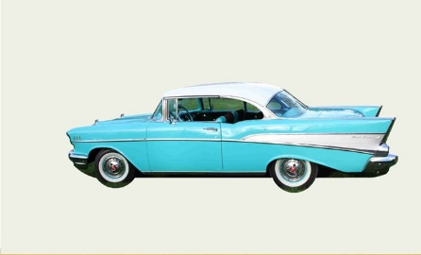
- 6am: Downtown street closes
  - 8am: Registration begins
    - 9am: Show Starts
      - 12:00 noon Balloting
Hospitality Tent 6-9am
        - 3pm: Awards presentations
          - Burn-out contest 1pm
Phone: 989-288-3715 Fax: 989-288-5177
Hosted by the Durand Area Chamber of Commerce
Email: office@durandchamber.com
-----------------------------------------------------------------------------------------------------
Registration Form – Early-bird fee (before August 18) $12.00 - After August 18: $15.00
Return this portion with check or credit card payable to: Durand Area Chamber of Commerce, PO Box 101, Durand, MI 48429. To pay by credit card please call the office
Name: _______________________________________________ Phone: _____________________

Address: _____________________________________________ E-Mail ______________________

City: _______________________________ State: ______________________ Zip: ______________

Car Year: ____________ Make: _________________ Model: _______________________________

_____ Yes! I want a custom cruise T-shirt(s) for $20. How many? ____ Size(s)? ___________
Swap Meet Early Bird $20__________After August 18-$25_____
Total enclosed for shirts,swap & registration: $______
Note: Neither the Durand Chamber of Commerce nor the City of Durand will be held responsible for accidents, injuries, or property damage occurring prior to, during, or after the show. I understand the above. No Refunds. Please, no alcoholic beverages or pets. Thank you!

Signature ________________________________________________________________________________________

